**ADVANCEMENT IN AUTOMATION OF SHIRODHARA TREATMENT**

***Project Phase-I report submitted***

***in***

***Partial fulfillment of requirement for the award of degree of***

**Bachelor of Engineering**

**in**

**Electronics Engineering**

***By***

**Ms. Rachi Ashtekar Mr. Ujjain Patil**

**Ms. Ruchika Choudhry Mr. Bhavesh Sahare**

**Mr. Rutuparna Ramteke Mr. Gaurav Dongre**

***Guide***

**Prof. Trushna Deotale**



**Department of Electronics Engineering**

G H Raisoni College of Engineering, Nagpur

(An Autonomous Institute affiliated to Rashtrasant Tukadoji Maharaj Nagpur University, Nagpur)

Accredited by NAAC with “A+” Grade

Ranked 130th by NIRF, MHRD in the Engineering category for India Ranking 2021

Ranked 2nd by ARIIA 2020, MHRD in private or self Finance Institute, 5 Star Rating by

MIC, MHRD 2021

**DEC 2021**

**Declaration**

We, hereby declare that the project phase-I report titled “**Automation of Shirodhara process** ” submitted herein has been carried out by us towards partial fulfillment of requirement for the award of Degree of Bachelor of Engineering in Electronics Engineering. The work is original and has not been submitted earlier as a whole or in part for the award of any degree / diploma at this or any other Institution / University.

We also hereby assign to G H Raisoni College of Engineering, Nagpur all rights under copyright that may exist in and to the above work and any revised or expanded derivatives works based on the work as mentioned. Other work copied from references, manuals etc. are disclaimed.

**Place :- Nagpur Ms. Rachi Ashtekar**

**Date:- Ms. Ruchika Choudhry**

**Mr. Rutuparna Ramteke**

**Mr. Ujjain Patil**

**Mr. Bhavesh Sahare**

**Mr. Gaurav Dongre**

**Certificate**

The project phase-I report entitled as “**Automation of Shirodhara Process**” submitted by **Rachi Ashtekar, Ruchika Ramteke, Rutuparna Ramteke, Ujjain Patil, Bhavesh Sahare,** **Gaurav Dongre** for the award of Degree of Bachelor of Engineering in Electronics Engineering has been carried out under our supervision. The work is comprehensive, complete and fit for evaluation.

**Institute Guide**

**Prof. Trushna Deotale**

Department of Electronics Engineering

G H R C E, Nagpur

**Head**

**Dr. L. P. Thakre** **Director**

Department of Electronics Engineering

G H R C E, Nagpur

**Director**

**Dr. Sachin Untawale**

G H R C E, Nagpur

**Acknowledgment**

We take a great pleasure and immense pride in presenting our project report on **Automation of Shirodhara project.** The sense of achievement, comprehended without the earnest support provided by various people associated with us.

We are extremely grateful to our project guide **Prof. Trushna Deotale,** Electronics Engineering for guidance throughout the project work. In addition to this experience and acknowledge of our guide has been our motivation during the project work.

We respect and thanks to **Dr. N.P. Wyawahare**, Major Project In Charge, for giving us all support and guidance which made us complete the project duly.

We additionally stretch out my true gratitude to the Head of Electronics Engineering, **Dr. Laxman P. Thakre** whose guidance and cooperation has motivated me at every level of our project.

We extend thanks to our respected Director **Dr. Sachin Untawale** whose efficient Management administration made the environment conductive for me to developed the Project.

Last but not the least, we are thankful to all staff member and fellow of our college who directly or indirectly have helped us.

**Abstract**

Shirodhara (dripping of fluid on forehead) is a popular ayurvedic treatment for relieving the headache and stress. Shirodhara induces a peaceful state of awareness that results in a dynamic psycho-somatic balance. The present study was conducted on 40 cases of primary headache for 15 days duration with an objective of clinical efficacy evaluation of Shirodhara with water and Shirodhara with water and Ashwagandha (Withania somnifera) extract orally in the management of headache along with associated anxiety and depression. The patients were randomly divided into two groups of 20 each. It was observed that the patients of group B treated with water shirodhara and Ashwagandha (Withania somnifera) extract (500 mg once a day) have shown significant improvement, whereas the group A treated with only Shirodhara with water also showed similar improvement. In modern developed world, youngsters and even older generation to some extents are leading a stressful hyperactive and physically-mentally demanding lifestyle, often working late hours in offices and being cut-off from nature and its care for extended period of time as a result of this hectic lifestyle, human psych has failed to cope with rapid changes of health pattern.

**Key words**: Shirodhara, Aswagandha, Anxiety, Stress, Depression, Primary headache

**LIST OF FIGURES**

|  |  |  |  |
| --- | --- | --- | --- |
| Sr No | Fig No | Name of Figure | Page No |
| 1 | 1 | Flow Chart | 15 |
| 2 | 2 | Copper pot with rotter machine | 17 |
| 3 | 3 | Copper Pots | 17 |
| 4 | 4 | 4 Wire Stepper motor | 19 |
| 5 | 5 | Submersiblewaterpump | 20 |
| 6 | 6 | LM35 | 21 |
| 7 | 7 | HC05 Bluetooth module | 23 |
| 8 | 8 | 8 channel 5v Relay Module | 24 |
| 9 | 9 | Aluminium Round Handi | 24 |
| 10 | 10 | Temperature Sensor | 25 |
| 11 | 11 | LCD Screen | 26 |
| 12 | 12 | Adaptor 24v ERD | 26 |

**INDEX**

|  |  |  |
| --- | --- | --- |
| **Sr No** | **Content** | **Page No** |
| Chapter 1 | Introduction   * 1. Different Types of Shirodhara Massage   2. Procedure   3. Shirodhara oil Ingredients   4. Who Should not Go for Shirodhara   5. What are the Benefits of Shirodhara Treatment   6. Aim of the Project | 1 |
| Chapter 2 | Literature Review | 6 |
| Chapter 3 | Methodology  3.1 Flow Chart  3.2 Module 1  3.3 Module 2  3.4 Comparison Between Existing model and our model | 15 |
| Chapter 4 | Hardware used | 27 |
| Chapter 5 | Conclusion | 28 |
| Chapter 6 | References | 31 |
| Chapter 7 | Appendices | 35 |
| Chapter 8 | Plagarism Report | 38 |

**CHAPTER 1**

**INTRODUCTION**

**Introduction**

Shirodhara is an ancient method of Ayurvedic healing that can help one find harmony within the mind, body and spirit for holistic wellbeing. It is one of the most essential therapies mentioned in Ayurveda that can not only rejuvenate and purify the body but also relieves stress, mental fatigue and treats several disorders.

The word ‘Shirodhara’ is derived from two Sanskrit words – ‘Shiro’ meaning the head and ‘Dhara’ meaning stream, pour or flow. Together, it means to pour or drip lukewarm herbal oils on the forehead in a continuous stream. During the therapy, the oil is poured from a certain height for a specific time to allow it to run through the scalp and into the hair. It stimulates a vital point on the head called the ‘Ajna Marma’ or the ‘Maha-Marma’, which brings stability in the mind and consciousness. According to Ayurveda, the Ajna Marma is the key point through which vital life force or ‘Prana’ circulates. It is also known as the centre of intuition and is called the ‘Third-Eye Chakra’ as well.

In addition, Shirodhara balances the doshas in the body and enhances the functioning of the nervous system while delivering a truly rewarding and divine experience.

**1.1 Different Types of Shirodhara Massage**

Shirodhara is called by different names as per the classical Ayurvedic texts of Charak Samhita and Susruta Samhita, such as Sirothara, Shiro Sheka, Shiro Parisheka, Shirashek, etc. Mainly, they can be categorised into the following four types.

Kashayadhara: This Shirodhara therapy is performed with medicated herbal decoction called Kashayadhara. The type of oil and herbs used in this therapy are selected considering the health conditions of the individual and their purpose of seeking the therapy.

Thailadhara: Here, medicated oil is used in therapy.

Ksheerdhara: This Shirodhara therapy uses milk infused with herbs like vetiver roots,

sandalwood or camphor. During the therapy, the milk is maintained at room temperature.

1

Takradhara: The Takradhara is a form of Shirodhara that uses buttermilk infused with herbs for the therapy.

**1.2 Procedure**

Here’s a step by step breakdown of the Shirodhara therapy.

Before the procedure starts, your head and scalp will be thoroughly massaged with plenty of oil for about five to ten minutes.

You will be required to lie on your back on the massage table in the supine position.

A small pillow or towel will be placed under your neck for support.

The Shirodhara pot or equipment will be placed over you in such a way that the herbal oil from the pot falls right over your forehead.

The pot will then be filled with the herbal oil you want to use and slowly poured over your forehead. The therapist ensures that the oil pours out of the Shirodhara pot in continuous motion.

Now the pot is oscillated to pour the oil from one side of the forehead to the other.

The extra oil that has dripped down from the forehead can be recollected, reheated to the optimum temperature, and can be put back in the pot to repeat the process.

The procedure can last for somewhere around 20 to 30 minutes.

During the process, you will also be given a light head massage.

After the Shirodhara massage, the oil will be wiped off from your head following which you will be relaxing for about 30 to 60 minutes. This will allow the oil to seep deep into your scalp.

Some points to note while performing the Shirodhara therapy are –

Contraindications for Virechana

For the best results, Shirodhara should be performed either in the morning or in the evening.

In some health conditions, Shirodhara is combined with a full body massage or Abhyanga using medicated herbal oils.

After the procedure is complete, it is recommended to take a bath with warm water. To remove oil from the hair, medicated shampoos may be used.

Avoid taking caffeinated products for a few days after the therapy as that could negate the benefits of the treatment. Also, ensure to follow a Vata-pacifying diet.

2

**1.3 Shirodhara Oil Ingredients**

The oil or liquid to be used for Shirodhara Ayurvedic treatment are chosen based on the individual conditions and dosha imbalance. Generally, herbal oils along with buttermilk, coconut water, decoctions consisting of liquorice and milk are used as the ingredients of the liquid. One session may require about 2-3 litres of the massaging liquid, and they are known to treat a host of health conditions, such as memory loss, allergic rhinitis, hearing damage, vertigo, tinnitus, insomnia, eye diseases, sinusitis, Meniere’s disease, various neurological disorders as well as certain skin disorders like psoriasis.

The most commonly used Shirodhara oil is Ksheer Bala tailam, which is made from a mixture of sesame oil, Bala herb paste and cow’s milk. Other types of oil include Chandanadi tailam, Narayana tailam, Karpasasthyadi tailam and Dhanwantharam tailam. Sometimes, in the absence of these oils, sesame oils can be used for Shirodhara massage, and that will work just fine. The sesame oil is rich in active ingredients and antioxidants like sesamin, sesaminol and sesaminol that help in regulating the activity of serotonin in the brain. Moreover, Shirodhara benefits the body by relieving stress, promoting tranquillity and inducing peaceful sleep. For the treatment of people suffering from post-traumatic stress disorder, Shirodhara therapy may be performed with oils mixed with nervine herbs.

**1.4 Who Should Not Go For Shirodhara?**

Shirodhara should not be done in the following conditions:

* Women at the last stage of pregnancy
* People having allergic reaction towards oil
* People suffering from nausea, vomiting, fever, fatigue or excessive sweating conditions.
* People suffering from a neck injury, brain tumour, or have cuts or abrasions on the forehead.

3

**1.5 What Are the Benefits of Shirodhara Treatment?**

**1 Relieves Stress**

Stressful events may cause the body to go through physical or emotional changes that can make them anxious, frustrated and angry. Shirodhara treatment can help to significantly reduce the stress from the mind and body.

When warm herbal oils are poured on the forehead along with a light massage of the head, the body goes into a relaxation state, conserves energy, dilates the blood vessels and slows down the heart rate. Hence, Shirodhara therapy is crucial in the treatment of hypertension and arrhythmia.

As most of the diseases that exist today are in some way related to stressful lifestyles, minimising the impacts of stress is essential to ensure lifelong health. Shirodhara promotes tranquillity and calmness and counteracts stress. Even a single session of Shirodhara can help you fight the effects of stress for hours or days.

**2 Awakening Intuition**

The point between the eyebrows is considered as the ‘Third Eye’ in many Ayurvedic scriptures. As mentioned earlier, it is the centre of intuition and foresight as well as the point of spiritual awakening. Shirodhara benefits the mind as it stimulates this point and opens up the third eye leading to the free-flowing of one’s life forces or prana. It removes any blockages in the energy channels of the mind and helps the individual to look at events buried in their past from a viewpoint which wasn’t accessible earlier. Moreover, the downpour of the Shirodhara oil also helps them to gain immense mental clarity to deal with their past traumas, emotional experiences and unresolved pains.

**3 Improves Quality of Sleep**

Insomnia and sleep issues have become a common problem for individuals looking at the fast-paced lifestyle that most of us follow. The lack of or irregularity in sleep can be extremely exhausting and lead to lethargy, a decline in decision-making abilities and mental functions as well as negatively impact the physical and emotional wellbeing. Shirodhara treatment is known to reduce the cortisol levels in the body thereby alleviating the symptoms of stress and improving the quality and duration of sleep.

4

**4 Fights Anxiety**

Shirodhara therapy is a natural stress buster. With relaxing head massage and herbal oils, Shirodhara eliminates toxins from the head and enhances the cognitive functions of the brain. It regulates the levels of serotonin hormone in the body, which contributes to happiness and wellbeing of the individual. Consequently, it also reduces the symptoms of anxiety, like uneasiness, restlessness, cold hands and feet, etc.

**5 Pacifies Vata Doshas**

Aggravated Vata Dosha in the body can lead to unwanted and chaotic thoughts, forgetfulness, restlessness and lack of attention. Shirodhara is an excellent therapy and remedy to pacify the excess Vata Dosha. The balancing properties of the herbal oils used in Shirodhara counteract the cool, light and fluctuating nature of the Vata dosha thereby alleviating the symptoms of Vata imbalance.

**1.6 Aim of the project**

The Shirodhara Ayurvedic treatment is the most requested therapy by our patrons at Govardhan EcoVillage, and there are good reasons for that. The therapy offers a great sense of relaxation and induces soothing effects on the mind. It uses several Ayurvedic oils that not only soothes and nourishes the brain, but also treats a host of health anomalies, like stress, migraine, hypertension, and more.

At Govardhan EcoVillage, we believe that living harmoniously with nature and adopting Ayurvedic practices should be a part of our daily lives. We shouldn’t wait until there is a health disorder or problem. Shirodhara treatment offers countless benefits and is extremely beneficial for the mind and body.

5

**CHAPTER 2**

**LITERATURE REVIEW**

**Literature Review**

1. **Shreeraj D. Jumadel, Akash R. Deurkar2, A. Avish3,** **“Review Paper on Automatic Shirodhara Machine”. Published in International Research Journal of Engineering and Technology (IRJET),** **Volume: 08 Issue: 03 | Mar 2021**

In modern developed world, youngsters and even older generations to some extents are leading a stressful, hyperactive and physically-mentally demanding lifestyle, often working late hours in offices and being cut-off from nature and its care for extended periods of time. As a result of this hectic lifestyle, human psych has failed to cope with rapid change of health pattern, life styles, fast progresses of loneliness, not being appreciated, anger, stress and other psycho-somatic disorders People are now searching for solutions to such problems and fortunately there are many remedies available in the Ancient and time-tested science of Ayurveda. One such remedy to stress is the Ayurvedic process of Shirodhara. Shirodhara is a classical Ayurvedic procedure carried out in order to alleviate urdhava jatrugata (Disease of head and neck). The need for change with time in every field has led to the evolution of systematic development and instrumentation in Shirodhara procedure and equipment also. This paper is an attempt to overview the current developments, system requirements and changes in instrumentation of Shirodhara and to evaluate the benefits and shortcomings of the newer instrumentation

There is a close connection between our body and our mind. If there is a psychological factor affecting a medical condition, it is important to treat the psychological problem as well as the medical problem. According to Ayurveda, Vata (energy of human body) and Mana (mind) are mainly degraded in a psychic disease. Classical texts of Ayurveda consider Shirah Pradesh (head region) as Uttamanga(supreme) and a Pradhana Marma (prime weakness) which is where Prana (health and life force) of body resides and it controls the functions and resources of

the body. Its resourcefulness, functions, and specific procedures to safeguard and protect them have been mentioned in Dincharya.

6

our team could not find any paper with exact chemical composition of the oils used in the process or the exact temperature to which the oil is to be heated before treatment. Most of the literature available on Shirodhara and its developments involve relative composition of oil and the temperature range varies from paper to paper. Our team has reviewed multiple papers and have assumed the average values of the required parameters because of the scarcity of

research material and scientific literature for calculation purposes and design considerations after consulting our guide. Very few research articles and research papers have

been written with emphasis on the automation of Shirodhara process and its technical details, our team had to work mostly with the “Noiseless, Portable and Fully Microcontroller Based Automatic Shirodhara Panchkarma Machine” By Balaji Wattamwar, Pawar Chander, Tanmay Borade, Amol Arkilwad, for the inputs on previous automation developments in Shirodhara treatments. The design and control system of the incorporated in their system are very well documented but the set up is unaesthetic in nature along with a few shortcomings of its own.

The oil reservoir is open without covering, the electronic setup is not enclosed in a proper casing and there is no documented arrangementfor varying the height oftheDhara patra. The commercially available products work on these shortcomings but are expensive with average costs ranging upwards.

1. **Haramohan Moharana1, Arun Kumar Mahapatra 2, Laxmi Maharana3, Santosh kumar Singh4.** **‘’Therapeutic Efficacy and Mechanism of Action of Ayurvedic Shirodhara: An Evidence Based Review’’. Published in World Journal of Ayurveda Science,** **Wjas Volume II Issue 1 Jan 2017**

The word shirodhara is derived from Sanskrit language shiro (head) + dhara (to flow). Shirodhara is a form of independent snehana procedure, wherein involves gently pouring liquids over the forehead. The selection of the drug and duration depends upon various factors including characteristics of disease, chronicity, involvement of dosha, patient’s prakriti and environmental condition. There are various specialized forms of shirodhara such asTailadhara, Ksheeradhara, Takradhara, Jaladhara and Kwathadhara. Though classically this procedure is not described under the panchakarma, but it incorporated under snehana karma by the ayurvedic scholars. This procedure can be pradhan karma depending upon the condition of the

7

patient. Shirodhara is classically advised for many diseases like insomnia, attention deficit hyperactivity, disorder, anxiety disorders, phobia, depression, essential hypertension and other psychosomatic disorders. The present paper presents the evidence based approach of the classical Ayurvedic procedure “shirodhara”. Apart from this article provides an insight into the probable mode of action of shirodhara. MATERIAL AND METHODSPUBMED, MEDLINE, GOOGLE SCHOLAR and DHARA databases were searched for studies published with key words “Shirodhara,” “Ayurveda,” etc. clinical trials published in peer reviewed journals were only included in the review. Research articles in English language were only considered. Other languages were approved when there was an English abstract containing data essential for extraction. Articles were selected based on their relevance to the topic

The mechanism of action of Shirodhara is fully not understood yet. There are only a few research papers depicting the same. Uebaba et al (2008) evaluated the effect of Shirodhara

treatment on physiologic, biochemical, immunoloic, and psychometric parameters. This trial was randomized, controlled protocol involving a novel approach using a robotic system. It was observed that Plasma noradrenaline and urinary serotonin excretion decreased significantly more after Shirodhara treatment than in the control. Apart from this, Plasma levels of thyrotropin-releasing hormone, dopamine, and natural killer (NK) cell activity were different between control and Shirodhara treatment.1 This shows that shirodhara procedure has an anxiolytic effect. In a similar investigation, Dhuri et al (2013) evaluated the psychological and physiological effects of Shirodhara in healthy volunteers by monitoring the rating of mood and levels of stress, electrocardiogram (ECG), electroencephalogram (EEG), and selected biochemical markers of stress. 16 healthy human volunteer participated in the trial and were subjected to Shirodhara followed by Abhyanga (whole body massage). It was observed that there was a significant improvement in mood scores and the level of stress (P<0.001). Apart from this, significant decrease in rate of breathing and reduction in diastolic blood pressure along with reduction in heart rate was observed. The relaxed alert state, after Shirodhara, was co-related with an increase in alfa rhythm in EEG.2 Apart from this, the subject's feelings during shirodhara showed deep restfulness with less anxiety - as if the subjects were between the sleep and awake states. Study show that Shirodhara induce bradycardia and the relative suppression of LF/HF power spectrum density, which indicates lowered sympathetic tone. Expired gas analysis shows a decreased tidal volume and CO2 excretion.

8

1. **Nidhi Gupta 1*, Gopesh Mangal 2 PG Scholar, Department of Panchakarma, National Institute of Ayurveda, Jaipur, Rajasthan, India 2 Assistant Professor & Head, Department of Panchakarma, National Institute of Ayurveda, Jaipur, Rajashtan. ‘‘A Conceptual Study on Shirodhara Procedure’’ Published in International Journal of Research in Ayurveda and Pharmacy August 2019.**

Pouring of medicated Kwatha (Decoction) or oil on forehead is known as Shirodhara. Shirodhara is also a type of Bahya Snehana (external oleation therapy) as mentioned in Ayurveda. Shirodhara is mainly indicated in neurological and psychosomatic disorders. Today’s modern life style is full of stress and thus interfering the individual daily function. In current era the problems like insomnia, headache, facial paralysis, scalp psoriasis, hair fall

etc. are the most common and challenging conditions. But till now effective management for these complaints are still lacking. Hence it is the need of time to find out the safe and effective treatment modalities for these diseases. Thus an effort is made to rule out the efficacy of Shirodhara in different psychological disorder. The apparent mode of action of this procedure is not understood. Ayurveda mainly highlighted the outcomes of the procedure rather than its action. So a review of Samhita, Chikitsa Grantha, Nighantus and Ayurveda text with regard to Shirodhara was conducted. Indication and Contraindication and therapeutic efficacy of Shirodhara were noted during the study.

There are various form of Shirodhara such as Tailadhara Takradhara, Ksheeradhara, Jaladhara and Kvathadhara. Classically this procedure is not described under the Panchakarma, but it incorporated under Snehana karma. Murdhatailam has been described in the Ayurveda which is of four type’s viz. Shiroabhyanga, Shirosheka, Shiropichu, Shirobasti. These are superior in their succeeding order . It is one of Bahya Snehana (external oleation therapy) procedure in

which Snehan is applied in head or it is a procedure where in involves gently pouring liquids over of the forehead and has been indicated for psychosomatic disorders and neurological disorders etc. These disorders are not only the diseased condition but also affect the quality of life and cause anxiety, depression and work ability is decreased. In Ayurveda human body is compared to an inverted tree where the head is the main part of the body and other organ are its branches. So, the head controls every system, hence application of medicine in the form of Shirodhara, on the head can cure many diseases of different parts of the body.

9

Classically Shirodhara is advised for many diseases like Headache, Daha (burning sensation), Paka (Abscess), Vrana (Wound), Arunsika (Boils) etc. It also indicated in Ardhavbhedak (Migraine) Suryavarta (Type of headache). Application of oil does not follow any form of massage. By the employment of this procedure one can achieve all the benefits in dermatological condition of scalp as well as psychological disorders. It can be performed in painful conditions or ulcerations of the scalp also.

References regarding Shirodhara were collected from various textbook, published research papers, previous work done and compilation was done. Concept of Shirodhara and procedure was studied in detail Shirodhara is an important therapeutic measure in Ayurveda system of medicine, which has got worldwide popularity because of its simple administration and effectiveness in several disorders and life style diseases. It is a purifying and rejuvenating therapy which eliminates toxins and mental exhaustion as well as relives stress and any ill effects on the central nervous system. On the basis of above description, it is clear that Shirodhara has both the therapeutic effect of medicament and procedural effect. These can

be understood from the aspect of Ayurveda, mechanical and Marma science. Shirodhara can be used for treatment of scalp, hair and psychological disorders.

1. **Sujata Rajan a, * Manoj K. Shamkuwar b, Ankur Kumar Tanwar,** “**Impact of Shirodhara on biological markers of stress: A case study” Published in Journal of Ayurveda and Integrative Medicine, Received 9 July 2020, Received in revised for 9 January 2021, Accepted 11 January 2021, Available online 23 February 2021**

The unforgiving pace and complexity of modern life has greatly challenged our ability to live healthier and fully in the present moment. Industrialization, globalization, and competition in each sector lead to emotional stress and strain in life which is dangerous at the physical and mental levels. As per the classics of Ayurveda, chinta (stress) and atichintan (overthinking) are the causes of Rasavaha srotodushti which lead to many diseases. Shirodhara is an important healing technique of Ayurveda that has neuro-immuno-physio-psychological effects on the human body. Several studies have been carried out to evaluate the efficacy of Shirodhara in many diseases. A 35-yearold female patient with sleep deprivation, loss of concentration, and irritable mood symptoms was admitted to the hospital. She was assessed on the basis of the Profile Of Mood Score (POMS) questionnaire, Serum Cortisol (Sr. Cortisol), Dehydro-

10

epiandrosterone (DHEA). The patient was treated by Shirodhara with sesame oil for 14 days continuously.

Results were assessed by biomarkers of stress and by POMS score. At the end of Shiroadhara, there was significant improvement found in presenting complaints as well as on the POMS Score and Stress bio-markers. During or after the treatment, no adverse events were observed.© 2021 The Authors. Published by Elsevier B.V. on behalf of Institute of Transdisciplinary Health Sciences and Technology and World Ayurveda Foundation. This is an open access article under the CC BY-NC-ND

The human being has to face various challenges in day to day life because of a different kind of occupational, environmental, and social conditions. Such frustration and worry lead to stress which adversely affects our physical, social, mental, and spiritual health too. In the face of a transforming world, the maintenance of life is critically dependent on keeping our inner environment constant called “homeostasis” and which threatens the homeostasis termed

as stress. Prolonged or inadequate response to stressors can impair the growth and development of the human body resulting in endocrine, metabolic, autoimmune, and psychological disorders

. Both psychologically and biologically, men and women tend to respond differently to stress. But upon stress, women had greater subjective and behavioral emotional arousal, some

conditions, such as depression and anxiety, are more prevalent in women. We are dealing not only with physical challenges but with emotional stressors too. Financial pressure, the demands of the workplace, hectic schedules e all of these can contribute to increasing our stress levels. All kinds of worries can trigger body flight and fight response. Stress is a profound risk factor for almost all non ecommunicable diseases, including cardiovascular diseases, cancer, diabetes, neurological disease.

Shirodhara showed significant improvement in serum bio-markers of stress, which are reduced after Shirodhara. It provided significant relief in the grading of the POMS Score on the 07th and 14th day of Shirodhara. It showed marked improvement in the positive domain of the POMS score and decreased the negative domain value in the POMS Score. There was a significant reduction in systolic and diastolic blood pressure after Shirodhara. It showed

appropriate responsiveness to the stress system. This therapy found effective treatment in the management of stress.

11

1. **Jitendra Kumar1, Girish Singh2*, Bertrand Martin3, Ram Harsh Singh4**. **‘‘Clinical Assessment of the Impact of Shirodhara with water Treatment in the Management of Primary Headache with associated Anxiety and Depression” Published in Annals of Ayurvedic Medicine Vol-7 Issue-1-2 Jan.-June, 2018.**

Shirodhara (dripping of fluid on forehead) is a popular ayurvedic treatment for relieving the headache and stress. Shirodhara induces a peaceful state of awareness that results in a dynamic psycho-somatic balance. The present study was conducted on 40 cases of primary headache for 15 days duration with an objective of clinical efficacy evaluation of Shirodhara with water and Shirodhara with water and Ashwagandha (Withania somnifera) extract orally in the management of headache along with associated anxiety and depression. The patients were randomly divided into two groups of 20 each. It was observed that the patients of group B treated with water shirodhara and Ashwagandha (Withania somnifera) extract (500

mg once a day) have shown significant improvement, whereas the group A treated with only Shirodhara with water also showed similar improvement.

Ayurveda the traditional health care wisdom of orient, throughout its classics, has projected a regulated life style to maintain the healthy state of body and mind. Headache is one common disorder of the nervous system presented as primary and secondary headache. Primary

headaches are the disorders where headache and associated features occur in the absence of any obvious exogenous cause. The most common ones in the category are migraine,

tension-type headache, and cluster headache. Headache often results in considerable disability and a decrease in the patient’s quality of life. Secondary headaches are caused by exogenous diseases such as meningitis, intracranial hemorrhage, brain tumor, temporal arteritis

and glaucoma, etc. Headache disorders impose a significant burden on sufferers including impaired quality of life and financial cost. Repetitive headache episodes, and persisting

fear for the next one causes a significant disruption in the family life, social life and job. The long-term effort of coping with a chronic headache may predispose the victim.

Migraine is the second most common cause of headache. It is largely an episodic headache and associated with certain features such as sensitivity to light, sound, or movement; nausea and vomiting.

12

Migraine headache can precipitate following certain trigger factors, such as glare,

bright lights, and sounds etc. Tension-type headache is described as chronic headache syndrome. It is characterized by bilateral tight, band like discomfort. It is completely without accompanying features such as nausea, vomiting, photophobia, and aggravation with movement. Cluster headache is an uncommon form of primary headache (0.1%). In this case, pain is usually deep, retro orbital, often unbearable in intensity, non-fluctuating, and

explosive in nature. It is typically characterized by periodicity.

The present study conducted on 40 cases of primary headache for 15 days duration showed significant trend of reduction in degree of headache, level of anxiety and depression and level of stress. The procedure of treatment was simple, cost effective and patient friendly. The

therapeutic effect is most likely to be biophysical in nature instead of only pharmacological action i.e., the therapeutic effect of Dhara is not merely medicinal effect of the liquid

used but, it is also to a significant extent due to biophysical Dhara effect.

1. **Bhelawe Prajakta Bhaktaraj*, Ukey Sapana Amol 2, Belge Archana Raman31 PG Scholar, 2Assistant Professor, 3 Professor & HOD, Dept. of Swasthavritta, Shri Ayurved Mahavidyalaya, Nagpur, ‘‘Role of shirodhara in the management of stress-induced menstrual disorders: a review’’. Published in International Journal of Research in Indian Medicine July- Sept. 2021 Vol. 05th Issue:3rd**

In the midst of a fastpaced competitive lifestyle, everyone is affected by stress in some way. Stress plays an important role on the menstrual cycle which causes negative consequences on the menstrual cycle in females. Menstrual function is disrupted by stress that activates the hypothalamic–pituitaryadrenal (HPA) axis; it leads to menstrual cycle alterations. As a result of this activation, menstruation becomes unpleasant, painful. Ayurveda aims at preservation & promotion of health and prevention & cure of diseases through the concepts of positive physical and mental health. Shirodhara is a procedure of gentle pouring of a stream of lukewarm medicated oil or other liquid continuously & Steadily on the forehead specifically on the Agneya chakra.

13

AIMS &OBJECTIVES: 1. To analyze the effects of stress on menstrual disorders.

2. To study the efficacy of Shirodhara in stress induced menstrual disorders. MATERIAL & METHODS: Relevant literature is referred from the Samhitas, Sangraha Granthas and contemporary literature along with personal experience.

DISCUSSION: People are dealing with a variety of stress and are working hard to

get rid of them. A person's mental wellbeing is essential for effective care of the body.

CONCLUSION: Shirodhara is a therapy that rejuvenates the nervous system, releases emotions, opens the subtle channels, and brings bliss throughout the mind and body. This has a calming and relaxing effect on the brain. Shirodhara has a significant effect on a variety of

stress-induced menstrual disorders. subjective & unpleasant feeling of distress.

It is a normal psychological & physiological reaction to changes in someone’s environment which could be emotional, physical, social or cultural. There is a rising prevalence pattern of

stress disorders in society. Prevalence of all forms of stress is found 53% in COVID-19 pandemic. Stress affects body, mind, behavior in many ways & everyone experiences it differently. Several studies have identified stress as one of the key factors responsible for

menstrual irregularities. In addition, the COVID-19 pandemic had a significant impact on public mental health. A regular menstrual cycle indicates the female’s overall good health.

Abnormal cycles, with irregular, painful and heavy bleeding, disrupt one’s professional and personal life. And require evaluation as they may have a major harmful impact on future reproductive and general health. Research shows that there is a strong & significant association

between stress and menstrual Disorders.

With the rapid progress and advancement comes the disease burden created by psychological stress &n depression, which is engulfing our society. Stress induced menstrual disorders are the emerging factors in the current scenario, leading to irregular, painful and higher severity of menstrual symptoms in females.

14

**CHAPTER 3**

**METHODOLOGY**

**Methodology**

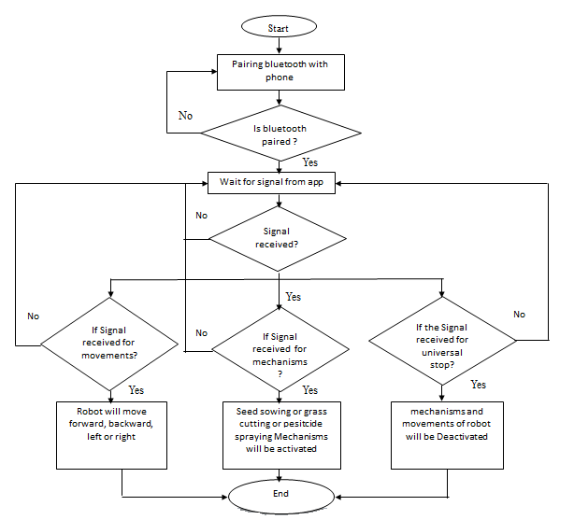

Fig no1: - Flow Chart

Our project consists of different modules- the first module will have electronic configured functioning tasks and another module will have hardware functioning.

The first module contains 1 handi or pot which will contain various medicated oil. These pots will have pumping motorsconfigured by Arduino uno Atmega328p, Bluetooth Module and Relay to sync our project.

15

Every pot will have a respective button on android phone, when we pass signal by phone to Bluetooth module, they will start pumping medicated oil from respective pot to a collector pot. Thermistor will regularly monitor the temperature on an LCD display screen.

After the oil gets heated to a lukewarm temperature i.e., at 35 degrees Celsius, another pumping motor will pump the oil with the help ATMEGA.

16 and relay. This pot will be suspended from our stepper motor enhanced suspender or mover that will act as a robotic hand to massage the forehead with our medicated oil.

In the last circuit unit After the patient has finished his therapy, the leftover oil will then be pumped to the collector pot from Module. If required, this oil can be reused for another therapy or stored back to its original pot by pressing the same button.

**For Module 1: - For Module 2: -**

Bluetooth Module

Power Supply

Relay units for operation on heaters and motors

Arduino

Servo Motor

Arduino

16

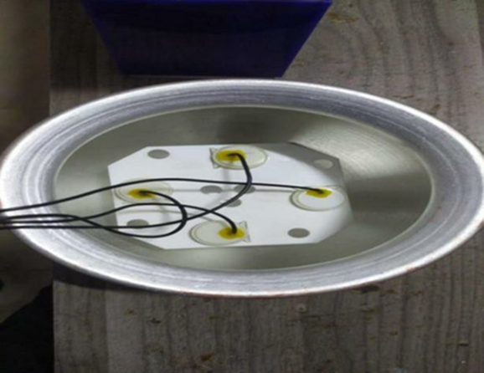

Fig no 2: - Copper pot with rotor Machine

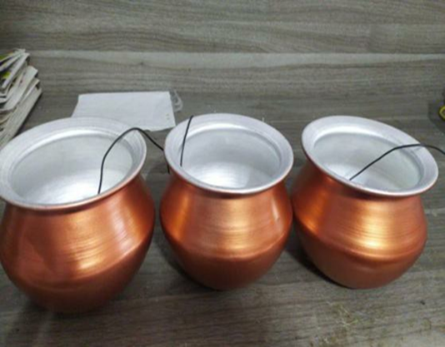

Fig no 3: - Copper pots

17

|  |  |
| --- | --- |
| Existing Model | Our Model |
| 1. This model controlled by switch 2. Only Automatic Heater 3. Only Display for heater 4. No Reversal System 5. Complex oil pipeline | 1. This model controlled by Bluetooth module      1. Automatic and manual operation for heater 2. LCD Display for better understanding 3. Reversal of oil to the pot 4. Compact system |

Table 1: - Comparison Between Existing model and Our model

18

**CHAPTER 4**

**HARDWARE USED**

**1. 4 wire stepper motor: -**

4 wire stepper motor is a bipolar stepper motor which should be driven in bipolar mode. Each phase has only one winding, therefore, the driving circuit is more complicated to reverse the pole, which is to reverse the current in the winding. In terms of structure, bipolar motors have multiple (at least two) independent windings. Each winding has a wire at the end, and each winding has two wires. 4 wire stepper motor has 2 leads in each phase, H Bridges with some driving topologies do have static friction effects, but this effect can be reduced by dithering stepper motor signals at higher frequencies. The stepper motor driver uses an h-bridge circuit to actually reverse the current flowing through the phase. All coils can be operated to rotate the stepper motor by alternating polarity excitation phase. Since all coils can be used, this stepper motor will get more torque. 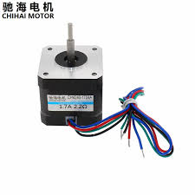

Fig no 3:- 4 wire stepper motor

* + Step Angle 1.8°
  + Holding Torque 4.2 Kg Cm.
  + Supply Current (A) 1.2 A/Phase
  + No. of Leads 4
  + Inductance 3.2mH/Phase.
  + RotorInertia 54gm-cm2
  + Weight(gm) 290
  + Dimensions(mm) L×W×H
  + Detent Torque(kg-cm) 40×42×42 0.22
  + Frame Size(mm) 42×42
  + Inductance Accuracy ±20%
  + Resistance Accuracy ±10%
  + Shaft Type D-type Shaft
  + Diameter(mm) 5 Shaft Length(mm)
  + 20Step Angle Accuracy ±5%
  + Cable Length 70mm

19

* + Shipment Dimensions 5 ×5 × 7cm

1. **SubmersibleMiniWaterpupm 3-6VDC: -**

DC 3-6 V Mini Micro Submersible Water Pump is a low cost, small size Submersible Pump Motor which can be operated from a 2.5 ~ 6V power supply. It can take up to 120 liters per hour with a very low current consumption of 220mA. Just connect tube pipe to the motor outlet, submerge it in water and power it. A submersible pump (or sub pump, electric submersible pump (ESP)) is a device which has a hermetically sealed motor close-coupled to the pump body. The whole assembly is submerged in the fluid to be pumped. The main advantage of this type of pump is that it prevents pump cavitation, a problem associated with a high elevation difference between the pump and the fluid surface. Submersible pumps push fluid to the surface, rather than jet pumps, which create a vacuum and rely upon atmospheric

pressure. Submersibles use pressurized fluid from the surface to drive a hydraulic motor

downhole, rather than an electric motor, and are used in heavy oil applications with heated

water as the motive fluid.

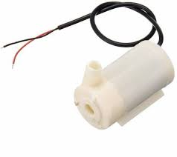

Fig no 5: - SubmersibleMiniWaterpump

**Specifications: -**

* Operating Voltage: 3 ~ 6V
* Operating Current: 130~
* 220mAFlow Rate: 80 ~ 120
* L/HMaximumLift: 40~110mm

20

* OutletOutsideDiameter: 7.5mm
* Outlet Inside Diameter: 5 mm
* Quantity: 4
* Cost: 49INRperpc

1. **LM35: -**

LM35 is a temperature sensor that outputs an analog signal which is proportional to the instantaneous temperature. The output voltage can easily be interpreted to obtain a temperature reading in Celsius. The advantage of lm35 over thermistor is it does not require any external calibration. The coating also protects it from self-heating. Low cost (approximately $0.95) and greater accuracy make it popular among hobbyists, DIY circuit makers, and students. Many low-end products take advantage of low cost, greater accuracy and used LM35 in their products. Its approximately 15+ years to its first release but the sensor is still surviving and is used in any products.

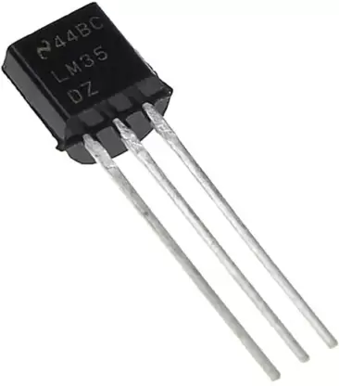

Fig no 6: - LM35

**Specifications:**

* Calibrated Directly in Celsius (Centigrade)
* Linear + 10-mV/°C Scale Factor
* 0.5°C Ensured Accuracy (at 25°C)
* Rated for Full −55°C to 150°C Range
* Suitable for Remote Applications
* Operates from 4 V to 30 V
* Less than 60-µA Current Drain

21

* Low Self-Heating, 0.08°C in Still Air
* Non-Linearity Only ±¼°C Typical
* Low-Impedance Output, 0.1 Ω for 1-mA Load

1. **HC 05 Bluetooth module: -**

HC 05 Bluetooth is a wireless communication protocol; it is used in two devices as a sending

and receiving the information. The Bluetooth is free to use in the wireless communication

protocol as the range of the Bluetooth is less than the other wireless communication

protocols like WiFi and Zigbee. The Bluetooth operates at the frequency of the 2.41 GHz and

also used in many small ranges of applications. It has 6 pins, **4.1 Key/EN:**

It is used to bring Bluetooth module in AT commands mode. If Key/EN pin is set to high,

then this module will work in command mode. Otherwise by default it is in data mode. The

default baud rate of HC-05 in command mode is 38400bps and 9600 in data mode. HC-05 module has two modes

**4.2 HC-05 module has two modes,**

• Data mode: Exchange of data between devices.

• Command mode: It uses AT commands which are used to change setting of HC-05. To

send these commands to module serial (USART) port is used.

2. VCC: Connect 5 V or 3.3 V to this Pin.

3. GND: Ground Pin of module.

4. TXD: Transmit Serial data (wirelessly received data by Bluetooth module transmitted out

serially on TXD pin)

**Bluetooth Module:**

5. RXD: Receive data serially (received data will be transmitted wirelessly by Bluetooth

module).

6.State: It tells whether module is connected or not.

22

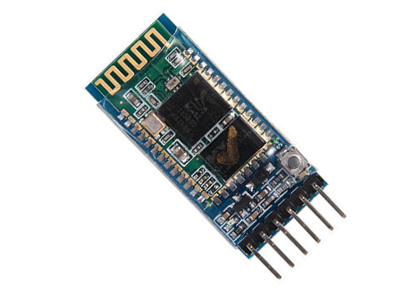

Fig no 7: - HC05 Bluetooth module

1. **8 Channel 5v Relay Module :-**

This is a 5V 8-Channels Relay module, it can be controlled directly by a wide range of

microcontrollers such as Arduino, AVR, PIC, ARM and MSP430.

8 relays are included in this module, with “NC” ports means “Normally connected to COM”

and “NO” ports mean “Normally open to COM”. This module also equipped with 8 LEDS to show the status of relays. **Specifications: -**

* One normally closed contact and one normally open contact
* Triode drive, increasing relay coil High
* impedance controller pin
* Pull-down circuit for avoidance of
* Malfunction Power supply indicator and Control
* nel:8channels.
* RelayOperatingVoltage:5V
* Power supply and relay instructions, lit, disconnect is off; Input signal, signal, commonTerminal and start conducting.
* Input signal, signal, common Terminal and startconducting; Usefulfo
* rappliancecontrol;
* DC or AC signal, control, you can controlthe220VACload;
* Quantity = 1
* Cost=269INR

23

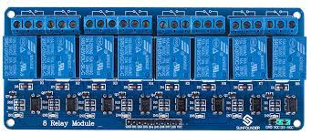

Fig no 8: - 8Channel 5v relay module

1. **Aluminum Round Handi: -**

* Quantity=3
* Cost=230INRperpc

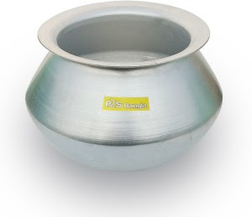

Fig no 9: - Aluminum round Handi

1. **Tempreature sensor**

A temperature sensor is a device used to measure temperature. This can be air temperature, liquid temperature or the temperature of solid matter. There are different types of temperature sensors available and they each use different technologies and principles to take the temperature measurement. Temperature Sensors measure the amount of heat energy or even coldness that is generated by an object or system, allowing us to “sense” or detect any

physical change to that temperature producing either an analogue or digital output.

24

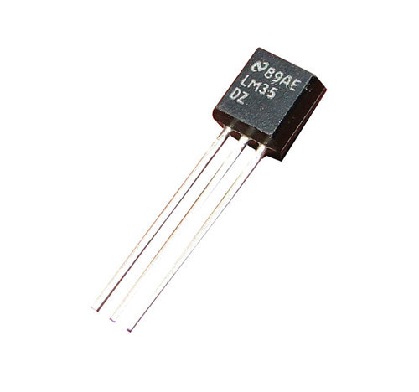

Fig no 10: - Temperature Sensor

1. **LCD Screen: -**

A liquid-crystal display (LCD) is a flat-panel display or other electronically modulated optical device that uses the light-modulating properties of liquid crystals combined with polarizers. Liquid crystals do not emit light directly, instead using a backlight or reflector to produce images in color or monochrome. LCDs are available to display arbitrary images (as in a general-purpose computer display) or fixed images with low information content, which can be displayed or hidden. For instance: preset words, digits, and seven-segment displays, as in a digital clock, are all good examples of devices with these displays. They use the same basic technology, except that arbitrary images are made from a matrix of small pixels, while other displays have larger elements. LCDs can either be normally on (positive) or off (negative), depending on the polarizer arrangement. For example, a character positive LCD with a backlight will have black lettering on a background that is the color of the backlight, and a character negative LCD will have a black background with the letters being of the same color as the backlight. Optical filters are added to white on blue LCDs to give them their characteristic appearance.

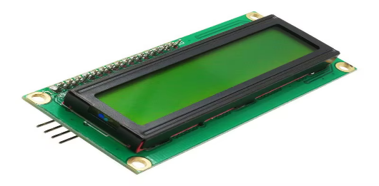

Fig no 11: - LCD Screen

25

1. **Adaptor 24v ERD: -**

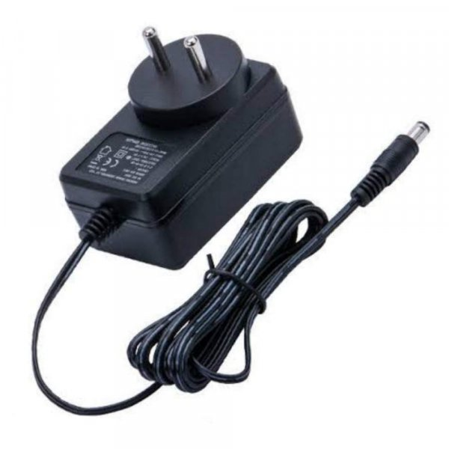

Fig no 12: - Adaptor 24 V ERD

26

**CHAPTER 5**

**CONCLUSION**

**Conclusion**

In a life filled with stress and work, everybody needs to pause their life for an hour

and boost their energy.

* We realized that in order to escape to an extended peace of mind, Shirodhara is a
* go-to-place for everyone in this world.
* Our project is just one of the providers of such treatment. This very cost effective
* and easy to use automatic/wireless Shirodhara machine also saves a lot of time and
* cuts the distance of travelling to an Ayurvedic center to get such therapy.
* In addition, it also recycles the medicated oil that we are using throughout our
* treatment.
* In conclusion, the flexibility of our project is enormous, it performs every basic
* function that a trained human does while being cost-effective and eco-friendly.
* Most importantly, this therapy can be performed from anywhere to anyone.
* Technology changes every second, by the time we are developing this project there
* can be more advanced ways of doing this. Following are the few things that can be
* implemented in this project.
* Face recognition technique can be used to detect the presence under the dropping
* vessel.
* The Use of more normal vessels for different methods make the overall project a bit
* complex and it can be reduced in coming versions.

27

**CHAPTER 6**

**REFERNCES**

**References**

1. Acharya JT, editor. 1st ed. Ch. 4. Varanasi: Krishnadas Academy; 2008. Dalhanacharya;

Commentary Nibandhasangraha on Sushrut Samhita of Sushruta, SootrSthana; p. 18.

2. Xu F, Uebaba K, Ogawa H, Tatsuse T, Wang BH, Hisajima T, et al. Pharmaco-physiopsychologic effect of Ayurvedic oil-dripping treatment using an essential oil from

Lavendula angustifolia. J Altern Complement Med. 2008; 14:947–56.

3. Kajaria D., Tripathi J., Tiwari S. An appraisal of the mechanism of action of shirodhara.

Ann Ayur Med. 2013;2(3):114–117.

4. PG Scholar, 2PG Scholar, 3PG Scholar, 4Head and Associate Professor, Department of

Panchakrma, SDM College of Ayurveda, Hassan, Karnataka, India.

5. Journal of Ayurveda and Integrative Medicine

<https://www.journals.elsevier.com/journal-of-ayurveda-and-integrative-medicine>.

6. N. Schneiderman, G. Ironson, S.D. Siegel

Stress and health: psychological, behavioral, and biological determinants

Annu Rev Clin Psychol, 1 (1) (2005), pp. 607-628

View PDF Cross Ref View Record in Scopus Google Scholar

7. E. Charmandari, C. Tsigos, G. Chrousos

Endocrinology of the stress response

Annu Rev Physiol, 67 (67) (2005), pp. 259-284

View PDF Cross Ref View Record in Scopus Google Scholar

8. R. Verma, Y.P.S. Balhara, C.S. Gupta

Gender differences in stress response: role of developmental and biological determinants

Ind Psychiatr J, 20 (1) (2011), pp. 4-10

View Record in Scopus Google Scholar

28

9. T.M. Chaplin, K. Hong, K. Bergquist, R. Sinha

Gender differences in response to emotional stress: an assessment across subjective,

behavioral, and physiological domains and relations to alcohol craving

Alcohol Clin Exp Res, 32 (7) (2008), pp. 1242-1250

View PDF Cross Ref View Record in Scopus Google Scholar

10.Women and mental health

Health NIoM, National Institute of Mental Health, Bethesda, MD (2021)

20892-9663

https://www.nimh.nih.gov/health/topics/women-and-mental-health/index.shtml

Google Scholar

25

11.C. Kundu, V.D. Shukla, M.A. Santwani, N.N. Bhatt

The role of psychic factors in pathogenesis of essential hypertension and its management

by Shirodhara and SarpagandhaVati

Ayu, 31 (4) (2010), pp. 436-441

Google Scholar

12. Agnivesha

Charakasamhita of agnivesha

B. Tripathi (Ed.), Charaksamhita. Vimanasthana; Srotovimanadhyaya: chapter 05, verse

13, Chaukhambha Surbharati Prakashan, Varanasi (2012), p. 699

View Record in Scopu sGoogle Scholar

13.Ibid, Chikitsasthana; Vatavyadhichikisaadhyaya: chapter 28, verse 16. p. 937.

Google Scholar

14.B. Tripathi (Ed.), Agnivesha. Charakasamhita of agnivesha. Chikitsasthana;

Unmadachikisaadhyaya: chapter 09, verse 09, ChaukhambhaSurbharatiPrakashan,

Varanasi (2012) Google Scholar

29

15.T. Shreekumar (Ed.), Vagbhata. AstangaHridaya by Vagbhata (1 ed.), Harishree Hospital,

Mannuthy, Kerala, India (2008), p. 29

Google Scholar

16.S.P. Vinjamury, M. Vinjamury, C. der Martirosian, J. Miller

Ayurvedic therapy (shirodhara) for insomnia: a case series

Glob Adv Health Med, 3 (1) (2014), pp. 75-80

View PDF Cross Ref View Record in Scopus Google Scholar

17.Anonymous. Dharakalpa

J.P. Shukla (Ed.), Prayag: Sudha Nidhi Granthavali (1981), pp. 9-10

30

**CHAPTER 7**

**APPENDICES**

**Appendices**

**Program: -**

**code 1: -**

//variable to store temperature in degree Celsius

#include <LiquidCrystal_I2C.h>

LiquidCrystal_I2C lcd (0x27, 16, 2);

//temporary variable to hold sensor reading

char data;

void setup ()

{

Serial.begin(9600);

lcd. in it (); // initialize the lcd

lcd. backlight ();

delay (50);

pinMode (5, OUTPUT) ;// In 5

pinMode (4, OUTPUT) ;// In 4

pinMode (3, OUTPUT);

pinMode (2, OUTPUT);

pinMode (6, OUTPUT) ;// In 6

pinMode (7, OUTPUT) ;// In 7

pinMode (8, OUTPUT);

pinMode (9, OUTPUT);

digital Write (2, HIGH);

digital Write (3, HIGH);

digital Write (4, HIGH);

digital Write (5, HIGH);

digital Write (6, HIGH);

digital Write (7, HIGH);

digital Write (8, HIGH);

digital Write (9, HIGH);

lcd.print("__Shirodhara__");

delay (1000);

31

Serial.begin(9600);}

void loop ()

{//here we combine both codes to work in the loop

bluetooth ();}

void bluetooth () {

{if (Serial.available()>0)

data = Serial.read();

Serial.print(data);}

if (data == 'A')

{digital Write (2, LOW);

lcd. clear ();

LCD. Print ("Heater ON");

delay (500);

lcd. set Cursor (1,10);}

if (data == 'a')

{digital Write (2, HIGH);

lcd. clear ();

LCD. Print ("Heater OFF");

lcd. set Cursor (1,10);}

if (data == 'B')

{digital Write (3, LOW);

lcd. clear ();

lcd. Print ("MAIN POT FEEDING");

lcd. set Cursor (0,1);}

if (data == 'b')

{digital Write (3, HIGH);

lcd. clear ();

lcd. Print ("POT STOP FEEDING");

lcd. set Cursor (0,1);}

if (data == 'C')

{digital Write (4, LOW);

lcd. clear ();

lcd. Print ("REVERSAL ON");

32

lcd. clear ();

lcd. set Cursor (0,1);}

29

if (data == 'c')

{digital Write (4, HIGH);

lcd. clear ();

lcd. Print ("REVERSAL OFF");

lcd. clear ();

lcd. set Cursor (0,1);}

else

{lcd. clear ();

lcd. Print("__Shirodhara__"); s}}

Code 2:

//variable to store temperature in degree Celsius

#include <LiquidCrystal_I2C.h>

LiquidCrystal_I2C lcd (0x27, 16, 2);

const int sensor=A1; // Assigning analog pin A1 to variable 'sensor'

float tempc;

float tempf; //variable to store temperature in Fahreinheit

float vout; //temporary variable to hold sensor reading

void setup ()

{

pinMode (sensor, INPUT); // Configuring pin A1 as input

Serial.begin(9600);

lcd. init (); // initialize the lcd

lcd. backlight ();

lcd. Print ("____Shirodhara ___");

delay (10000);

lcd. clear ();

delay (50);

}

void loop ()

{

33

vout=analogRead(sensor);

vout=(vout*500)/1023;

tempc=vout;

Serial.print (tempc);

tempf=(vout*1.8) +32;

delay (500);

lcd. clear ();

lcd. set Cursor (0,0);

lcd. Print ("temp in C=");

lcd.print(tempc);

delay (500);

30

delay (100);

if (tempc<=34.9)

{

digital Write (2, LOW);

lcd. set Cursor (0,0);

lcd. Print ("HEATOR ON ");

}

if (tempc>=35)

{

digital Write (2, HIGH);

lcd. set Cursor (0,0);

lcd. Print ("HEATOR ON ");}

34

**CHAPTER 8**

**PLAGARISM REPORT**

**Plagarism Report**



35

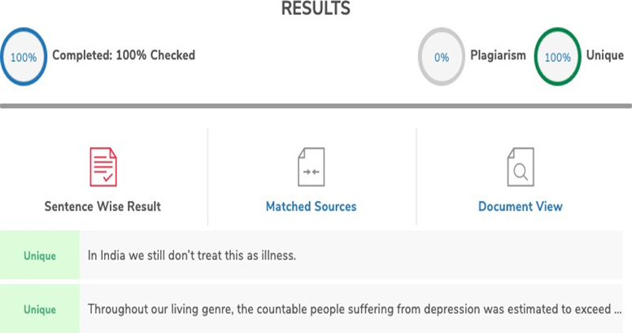

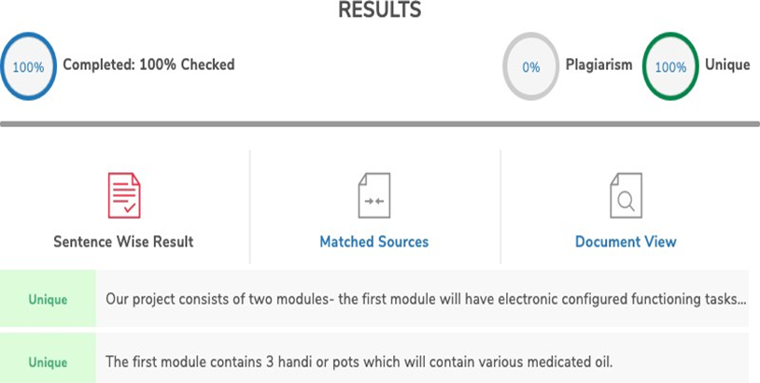

36

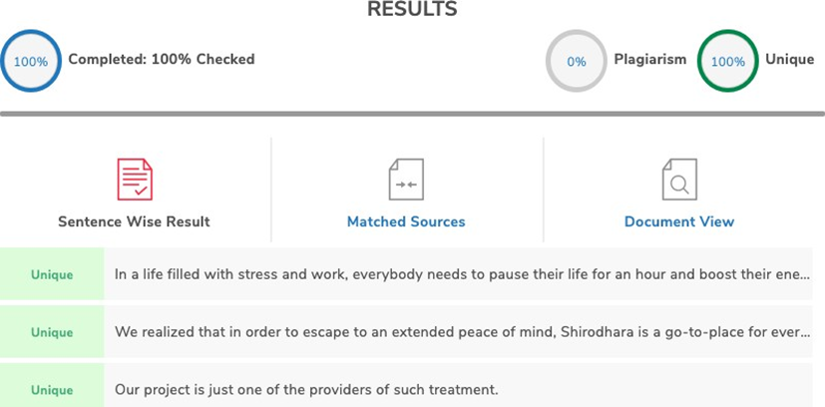

37

**Group Photo with Project Guide: -**

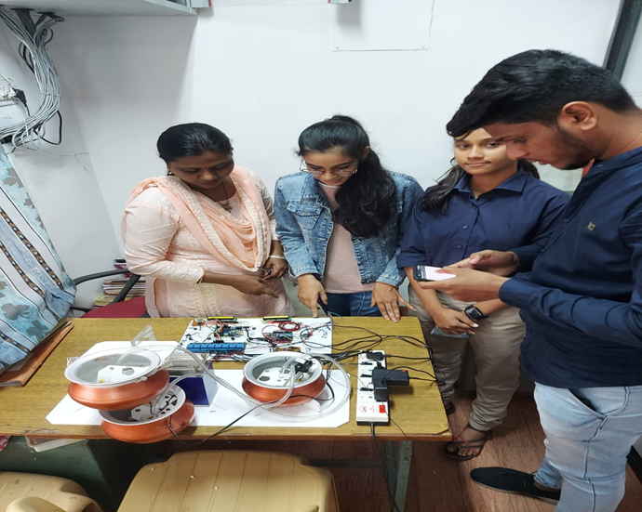

|  |  |  |  |  |
| --- | --- | --- | --- | --- |
| **Sr.no** | **Name** | **Roll no.** | **Phone No.** | **Email Id** |
| 1 | Rachi Ashtekar | B-03 | 7507006402 | ashtekar_rachi.ex@ghrce.raisoni.net |
| 2 | Ruchika Choudhary | B-06 | 9604144396 | choudhary_ruchika.ex@ghrce.raiaoni.net |
| 3 | Rutuparna Ramteke | B-42 | 8149389029 | ramteke_rutuparna.ex@ghrce.raisoni.net |
| 4 | Ujjain Patil | B-63 | 7249182197 | patil_ujjain.ex@ghrce.raisoni.net |
| 5 | Bhavesh Sahare | A-07 | 8668379736 | sahare_bhavesh.ex@ghrce.raisoni.net |
| 6 | Gaurav Dongre | A-02 | 8999987079 | dongre_gaurav.ex@ghrce.raisoni.net |

38